***ID: 1***

**Summary:** Button "Notes" do nothing when pushing it at main menu.

**Description:** Button "Notes" do nothing when pushing it at main menu;

**Actual result:** nothing is happening;

**Expected result:** Sidebar with preferences is opening;

**Environment:** Motorola XT1929-8, Android 9;

**Reproducibility:** always.

**Steps to reproduce:** 1. Open "Notes" app; 2. Push button "Notes".   
Severity: major.

Attachment (1 video):



***ID: 2***

**Summary:** Editor is opening with different color.

**Description:** Editor's color is silver while main menu color is black.

**Actual result:** Main menu and editor’s page have different color;

**Expected result:** Main menu and editor’s page have same color;

**Environment:** Motorola XT1929-8, Android 9;

**Reproducibility:** always.

**Steps to reproduce:** 1. Open "Notes" app; 2. Push button "New note".  
**Severity**: minor.

Attachment: 1 video



***ID: 3***

**Summary:** The application opens a new tab for the note;

**Description:** The application opens a new tab for any note: for a new or existing one.

**Actual result:** The application opens a new tab for work with any note;

**Expected result:** The application should work with notes on the same page as the main menu;

**Environment:** Motorola XT1929-8, Android 9;

**Reproducibility:** always.

**Steps to reproduce:** 1. Open "Notes" app; 2. Push button "New note" or select an existing one;

Severity: major.



***ID: 4***

**Summary:** The underline in the editor is too close to the text.

**Description:** The underline in the editor is too close to the text and letters such as “j”, “g”, “y”, “p” are crossing this line.

**Actual result:** letters such as “j”, “g”, “y”, “p” are crossing underline;

**Expected result:** letters such as “j”, “g”, “y”, “p” are not crossing underline;

**Environment:** Motorola XT1929-8, Android 9;

**Reproducibility:** always.

**Steps to reproduce:** 1. Open "Notes" app; 2. Push button "New note"; 3. Print letters “j”, “g”, “y”, “p”.

Severity: minor.

Attachment: 1 screenshot  
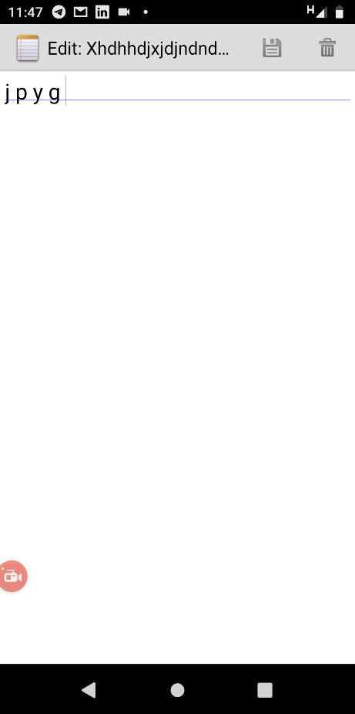

***ID: 5***

**Summary:** application“Notes” doesn’t delete notes;

**Description:** The application does not delete previously created notes and just returns to main menu without deleting.

**Actual result:** Return to main menu, note is not deleted;

**Expected result:** Return to main menu, note is deleted;

**Environment:** Motorola XT1929-8, Android 9;

**Reproducibility:** always.

**Steps to reproduce:** 1. Open "Notes" app; 2. Push button "New note"; 3. Print any letters, 4. Push button “Delete”.  
**Severity:** major.

**Attachment:** 1 video



***ID: 6***

**Summary:** applicationsave the notes without name;

**Description:** the app saves the notes without a title and words, returns back to the main page and leaves an empty line without words.

**Actual result:** An empty note saved and present in main menu;

**Expected result:** An empty note is not saved and the application in the main menu shows the last completed note;

**Environment:** Motorola XT1929-8, Android 9;

**Reproducibility:** always.

**Steps to reproduce:** 1. Open "Notes" app; 2. Push button "New note"; 3. Push “Save” button.

**Severity:** major.

**Attachment:** 1 Video



***ID: 7***

**Summary:** The app returns to the main menu without asking about saving.

**Description:** The application exits editing a note without a question about canceling changes if you press the virtual button "Back".;

**Actual result:** The application will return to the main menu and save the changes without asking if you want to save or discard the changes.;

**Expected result:** The application asks the question "Exit without saving changes?" if you click on the "Back" button.

**Environment:** Motorola XT1929-8, Android 9;

**Reproducibility:** always.

**Steps to reproduce:** 1. Open "Notes" app; 2. Push button "New note" or select an existing one; 3. Write any letters; 4. Press “Back” on the smartphone.

Severity: major.

***ID: 8***

**Summary:** The “Edit” button doesn’t work at editor’s page.

**Description:** The “Edit” button doesn’t work at editor’s page.;

**Actual result:** The “Edit” button doesn't not activate anything.

**Expected result:** The “Edit” button has to activate sidebar menu with prefirences;

**Environment:** Motorola XT1929-8, Android 9;

**Reproducibility:** always.

**Steps to reproduce:** 1. Open "Notes" app; 2. Push button "New note" or select an existing one; 3. Push “Edit” button.

**Severity:** major.

**Attachment:** 1 video



***ID: 9***

**Summary:** Notes app does not follow chronology.

**Description:** The application puts any of the open notes in the first position, even if the note has not changed.;

**Actual result:** Each open note goes to the first line of the note list.

**Expected result:** Each created note follows the previous one in chronological order and does not change position if changed.;

**Environment:** Motorola XT1929-8, Android 9;

**Reproducibility:** always.

**Steps to reproduce:** 1. Open "Notes" app; 2. Create any three notes; 3. Tap the last note; 4. Push “Back” on the smartphone.

**Severity:** major.

**Attachment:** 1 Video



***ID: 10***

**Summary:** The cursor crosses the underline.

**Description:** The cursor crosses the underline of the text on the page with the editor.;

**Actual result:** The cursor crosses the underline.

**Expected result:** The underline of the text must be below the cursor and must not cross the cursor.;

**Environment:** Motorola XT1929-8, Android 9;

**Reproducibility:** always.

**Steps to reproduce:** 1. Open "Notes" app; 2. Open any note or create new one.

**Severity:** minor.

**Attachment:** 1 screenshot.

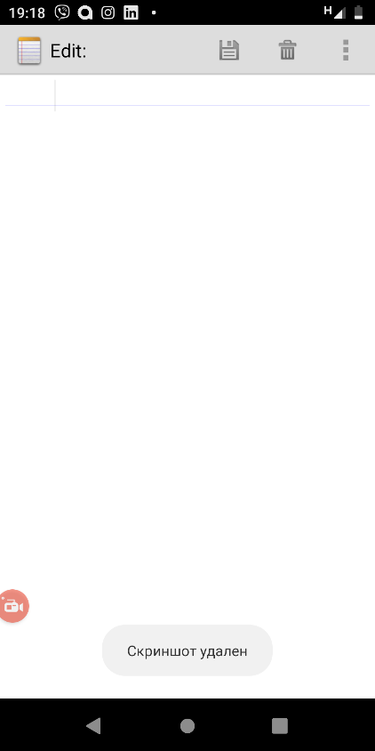

***ID: 11***

**Summary:** Notes do not contain creation dates;

**Description:** Notes do not contain creation or modification dates and times;

**Actual result:** Notes do not contain creation dates;

**Expected result:** In the main menu, on the right side of the title, each note have to contain the date and time of creation or last modification;

**Environment:** Motorola XT1929-8, Android 9;

**Reproducibility:** always.

**Steps to reproduce:** 1. Open "Notes" app; 2. See the list of notes or create on if the notes are not present.

Severity: minor.

***ID: 12***

**Summary:** “Notes” installs in different folder on the smartphone;

**Description:** “Notes” installs in different folder, not in folder “data”;

**Actual result:** “Notes” installs in different folder;

**Expected result:** “Notes” installs in folder “Data”;

**Environment:** Motorola XT1929-8, Android 9, Android Debug Bridge version 1.0.41;

**Reproducibility:** always.

**Steps to reproduce:** 1. Install the app; 2. Check “Data” folder for com.example.android.notepad.

**Severity:** major.

**Attachment**: 1 screenshot.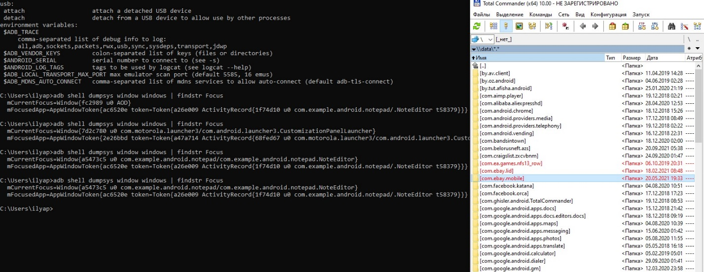

***ID: 13***

**Summary:** Application doesn’t have information about its version and developers;

**Description:** Application doesn’t have information about it. For example, button “About”, where located information about the app and developers.

**Actual result:** Application doesn’t have information about it;

**Expected result:** Application has to have information about it;

**Environment:** Motorola XT1929-8, Android 9;

**Reproducibility:** always.

**Steps to reproduce:**

**Severity:** Critical.

***ID: 14***

**Summary:** Application doesn’t flip the main menu;

**Description:** If you return to the main menu from the editor's widescreened page, the main menu remains vertical.

**Actual result:** Main menu still vertical;

**Expected result:** The main menu is as wide as the editor page.;

**Environment:** Motorola XT1929-8, Android 9;

**Reproducibility:** always.

**Steps to reproduce:** 1. Open "Notes" app; 2. Push button "New note" or select an existing one; 3. Switch to widescreen mode; 4. Return to main menu.

**Severity:** trivial.

**Attachments:** 1 Video

